Arrays and Strings in Bash Scripting

Arrays in Bash Scripting
- In Bash scripting, arrays are powerful tools for managing lists of elements or values.
- Unlike some programming languages, Bash arrays are always one-dimensional, but they can still be quite useful.
Declaring an Array

In Bash, arrays can be declared with or without specifying elements initially.

Empty array declaration:
declare -a array_name
Array with elements:
array_name=(value1 value2 value3)

Practice Questions
- How can you verify if an array has been declared in Bash, even if it is empty?
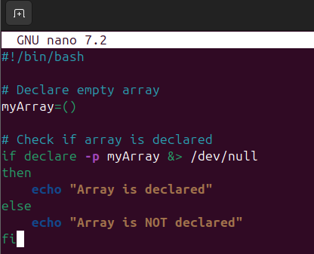
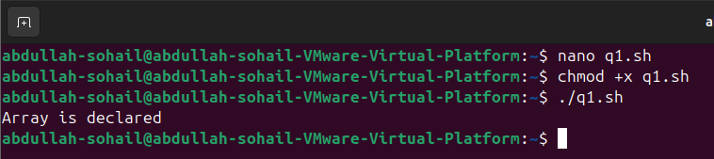

- How can you check if an array has been both declared and initialized (i.e., contains at least one element) in Bash?
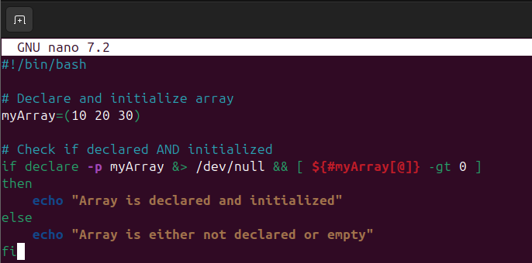
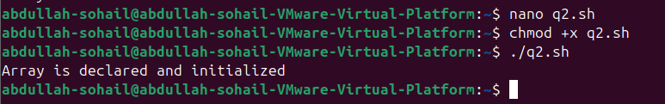

Accessing Array Elements

To access individual elements in an array, use the ${array_name[index]} syntax.

echo ${array_name[0]} # Access the first element
echo ${array_name[1]} # Access the second element

Access all elements:
echo ${array_name[@]} echo ${array_name[*]} elements
Adding and Modifying Elements

# Prints all elements in the array # Alternative to @, also prints all


You can add or update elements by assigning a value to a specific index.

array_name[3]="new_value" # Adds or updates the fourth element




Array Length

To find the number of elements in an array:
echo ${#array_name[@]} # Prints the number of elements
Looping Through Arrays

Use a for loop to iterate over elements in an array.

for element in "${array_name[@]}"; do echo $element
done

Or loop through indices:
for index in "${!array_name[@]}"; do
echo "Element at index $index: ${array_name[index]}"
done
Removing Elements

Use the unset command to remove an element at a specific index.
unset array_name[1] # Removes the second element
To clear the entire array:
unset array_name
Associative Arrays

Associative arrays (key-value pairs) are available in Bash 4.0 and above.

declare -A assoc_array assoc_array[key1]="value1" assoc_array[key2]="value2" # Accessing elements
echo ${assoc_array[key1]}
# Looping through associative arrays for key in "${!assoc_array[@]}"; do
echo "Key: $key, Value: ${assoc_array[$key]}" done


Example

Here's a full example of working with arrays in Bash:

# Declare and initialize an array fruits=("Apple" "Banana" "Cherry")

# Add an element fruits[3]="Date"

# Print all elements
echo "All fruits: ${fruits[@]}"

# Print length of the array
echo "Number of fruits: ${#fruits[@]}"

# Loop through elements
for fruit in "${fruits[@]}"; do echo "Fruit: $fruit"
done

# Remove an element
unset fruits[1] # Removes "Banana"

# Print all elements after removal
echo "Fruits after removal: ${fruits[@]}"

Practice Questions
- Write a Bash script that stores the names of all .txt files in a directory into an array and then prints the array.

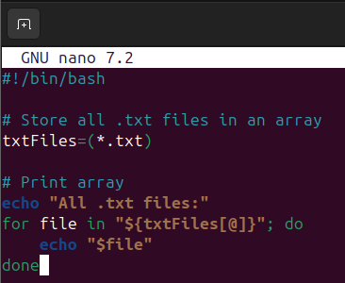
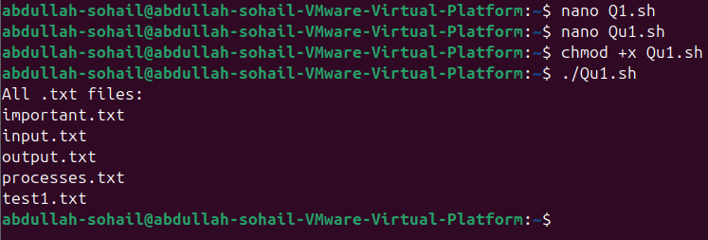
- Write a script that stores the names of all .txt files in an array and then counts the number of lines in each file.
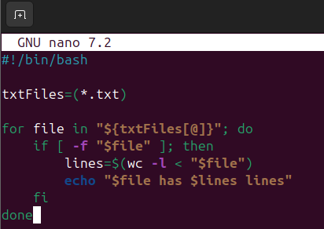
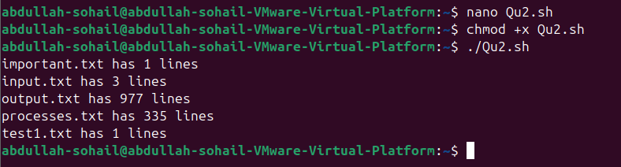

- Write a script that stores the names of all .txt files in an array and then finds files larger than a specified size (e.g., 1000 bytes).
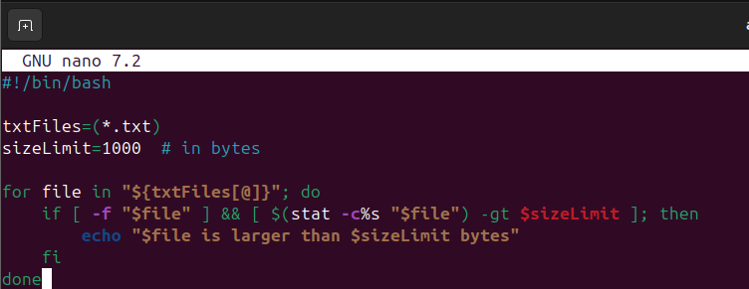

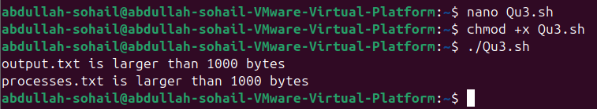

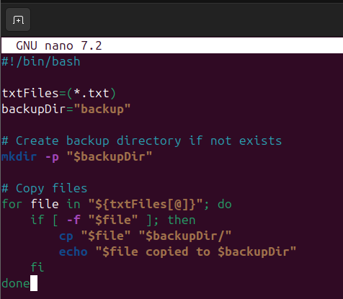
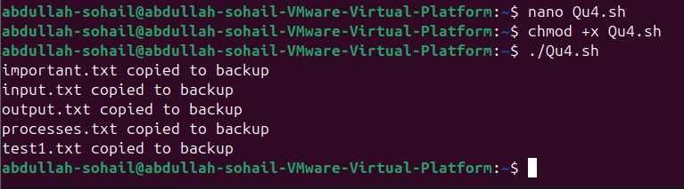
- Write a script that stores the names of all .txt files in an array and copies them to a backup directory.

- Write a script that stores the names of all .txt files in an array and lists those that contain more than 100 words.

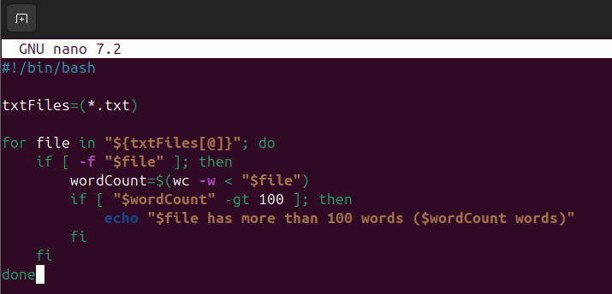
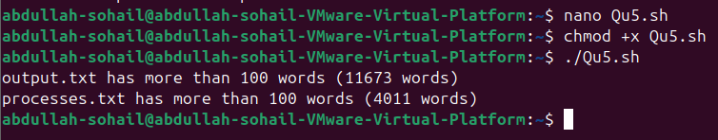
- Write a script that stores the names of all .txt files in an array and deletes those that are empty.
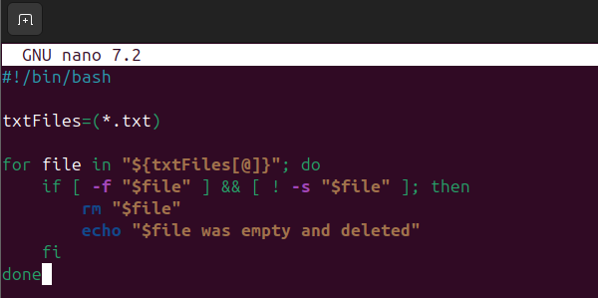

Strings in Bash Scripting
  - In Bash scripting, strings are one of the most common data types you'll work with.
  - Here’s an overview of string handling in Bash, from basic to advanced concepts:

Basic String Assignment

Assigning a String to a Variable:
name="John"
echo $name

Concatenating Strings:

first_name="John" last_name="Doe"
full_name="$first_name $last_name" echo $full_name
Accessing String Length


Getting the Length of a String:
str="Hello, world!"
echo ${#str} # Outputs: 13
String Comparison

Comparing Strings Using == and !=:

str1="apple"
str2="banana"
if [ "$str1" == "$str2" ]; then echo "Strings are equal"
else
echo "Strings are not equal"
fi

String Comparison with -z (Check if the string is empty):
str=""
if [ -z "$str" ]; then echo "String is empty"
else
echo "String is not empty"
fi

String Comparison with -n (Check if the string is not empty):
str="Hello"
if [ -n "$str" ]; then
echo "String is not empty"
else
echo "String is empty"
fi
String Manipulation

Substring Extraction:
str="Hello, world!"
echo ${str:7:5} # Outputs: world

Extracting a Substring from the End of a String:
str="Hello, world!"
echo ${str: -6} # Outputs: world!

String Replacement:
str="Hello, world!" new_str=${str/world/universe} 'universe'

# Replaces 'world' with







echo $new_str # Outputs: Hello, universe!

Remove Leading or Trailing Whitespaces:
str=" Hello, world! "
trimmed_str=$(echo "$str" | xargs) # Removes leading and trailing whitespaces
echo "$trimmed_str" # Outputs: Hello, world!






Advanced String Operations

String Splitting (Using IFS and read):
str="apple,banana,orange"
IFS=',' read -ra arr <<< "$str" # Splits string by comma into an array
for i in "${arr[@]}"; do
echo $i # Outputs: apple, banana, orange
done

Using printf for String Formatting:
name="Alice"
age=25
printf "Name: %s\nAge: %d\n" "$name" "$age"

String Matching with Regular Expressions (using [[ ... ]]):
str="Hello, world!"
if [[ "$str" =~ ^Hello ]]; then
echo "String starts with 'Hello'"
else
echo "String does not start with 'Hello'"
fi

String Case Conversion:
str="Hello, world!"
# Convert to uppercase
echo ${str^^} # Outputs: HELLO, WORLD! # Convert to lowercase
echo ${str,,} # Outputs: hello, world!

Checking If a String Matches a Pattern:
str="abc123"

if [[ "$str" == abc* ]]; then
echo "String starts with 'abc'"
fi

String Functions in Bash

Using tr to Transform Characters:
echo "Hello, World!" | tr 'a-z' 'A-Z' uppercase

# Converts to








Using sed for String Substitution:
str="Hello, world!"
echo "$str" | sed 's/world/universe/' # Outputs: Hello, universe!
Using awk for String Manipulation:
str="apple banana cherry"
echo "$str" | awk '{print $2}' # Outputs: banana
String Arrays

Declaring an Array of Strings:
fruits=("apple" "banana" "cherry") echo ${fruits[0]} # Outputs: apple
Looping Through an Array of Strings:
fruits=("apple" "banana" "cherry")

for fruit in "${fruits[@]}"; do
echo $fruit # Outputs: apple, banana, cherry
done
Handling Multiline Strings

Multiline String Declaration: str="This is a multiline string in Bash."
echo "$str"

Here Document (Heredoc) for Multiline Strings:
cat << EOF
This is a multiline string
using a here document. EOF

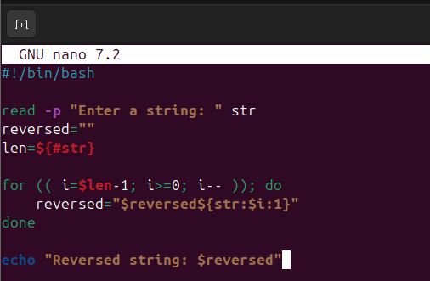
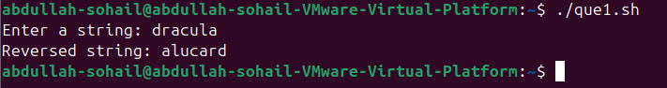
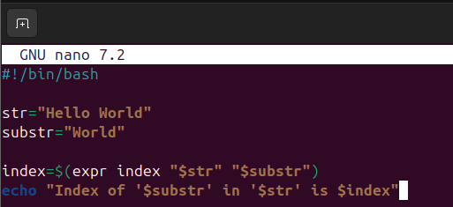
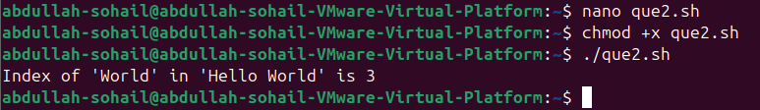
Practice Questions
- Write a script to reverse a string using Bash string manipulation techniques.

- Write a script to find the index of a substring in a given string.

- Write a script to check if one string contains another string.
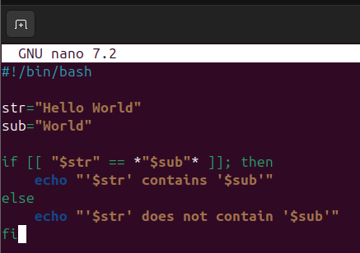
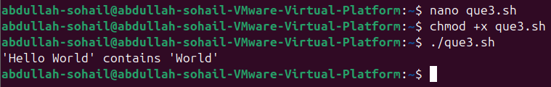

- Write a script to format and display a string that includes variables for a name and age.
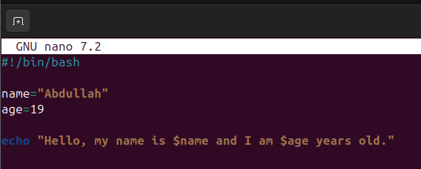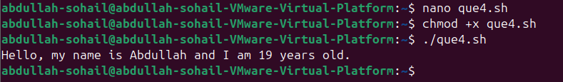
- Write a script that takes a comma-separated string and splits it into an array, then prints each item.

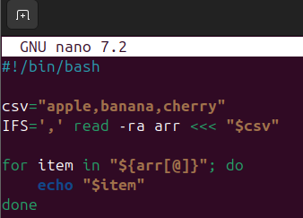
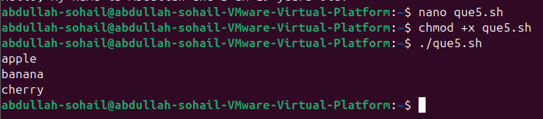
- Write a script to count the number of lines in a file that contain a specific string.
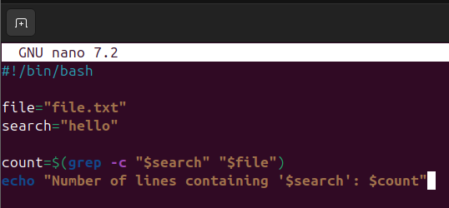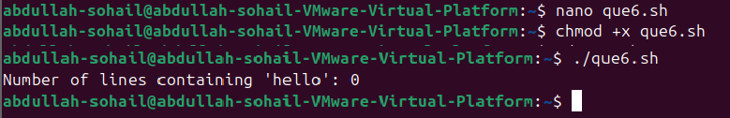
- Write a script to extract all lines containing a specific string from a file and save them into a new file.

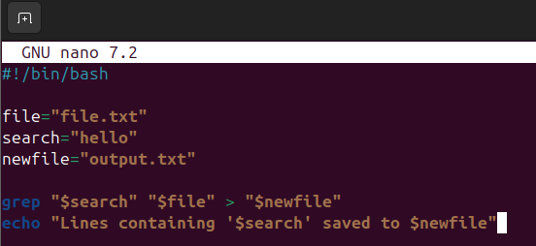
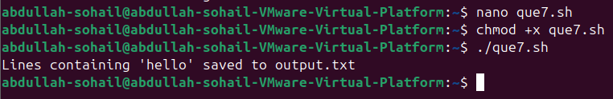
- Write a script to replace a string in a file with another string.
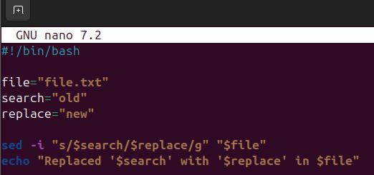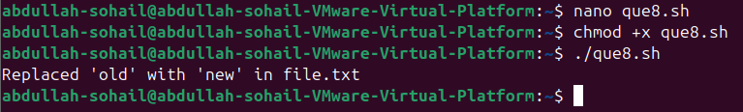
- Write a script to print all the lines from a file that do not contain a specific string.
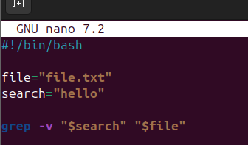

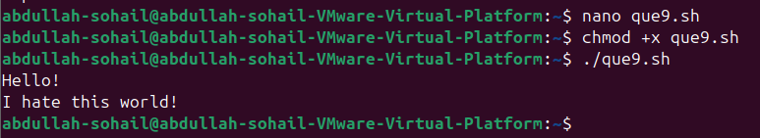
- Write a script to count and print the number of occurrences of a specific string in a file.
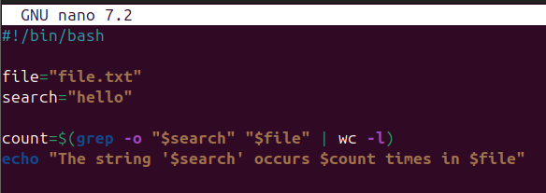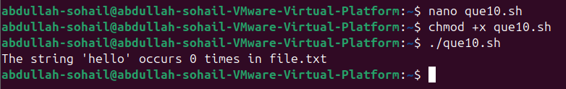
- Write a script to append a string to the end of a file.
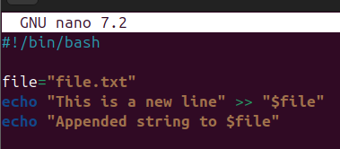
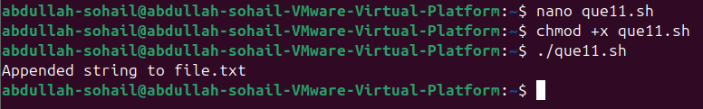

- Write a script to remove all empty lines from a file
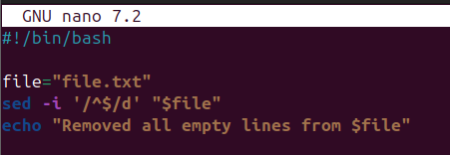

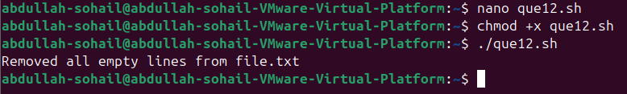
- Write a script to count the number of words in a file.
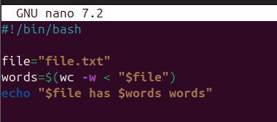

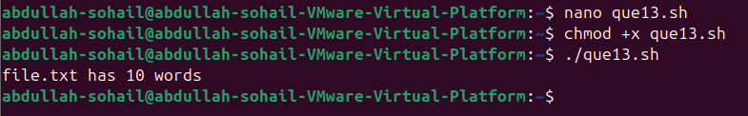
- Write a script to search for a string in a file and print the line number of each occurrence.
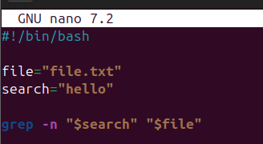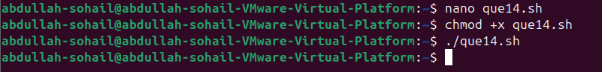
- Write a script to delete a line from a file that contains a specific string.
